1
.
Entryways
and
Exterior
This week
Lighting · non-slip
seat height · levers
under $100
Next month or two
Grab bars fitted · front step
get quotes
$150 to $15,000
Plan and budget
Shower conversion · doorway widening
$6,000 and up
Blocking goes in while the wall is open
Almost free during a build. Opening the wall again later is not.
The order work usually goes in. Cheap and reversible first, because it addresses where falls happen and needs nobody. The dependency worth knowing is at the bottom:
blocking behind a wall costs almost nothing while the wall is open and means a grab bar can go anywhere later.
How to Use This Checklist
Walk through each room with this list, on screen or printed. Check off what is already done. Flag what needs
attention. The bathroom and entryways are the highest priority. Start there.
Consider a professional assessment too:
A CAPS (Certified Aging in Place Specialist) can assess your home for
$150-500 and catch things a self-assessment misses.
The entry is where falls happen before anyone gets inside. A few changes here remove the biggest trip hazards.
☐
No-step entry or a low-slope ramp (max 1:12 slope) at the main entrance
☐
Grab bar at the front door, mounted to a stud, not just drywall
☐
Motion-activated exterior lights on all entry paths
☐
Lever-style door handles on all exterior doors (round knobs are hard to grip with arthritis)
☐
Slip-resistant doormat that lies flat and does not bunch at edges
The order work usually goes in. Cheap and reversible first, because it addresses where falls happen and needs nobody. The dependency worth knowing is at the bottom: blocking behind a wall costs almost nothing while the wall is open and means a grab bar can go anywhere later.
Keyless entry lock or smart lock (eliminates fumbling with keys at night)
☐
Pathway lighting from driveway or garage to front door
☐
Handrail on all porch or front steps, even if just one or two steps
2
.
Living
Room
This week
Lighting · non-slip
seat height · levers
under $100
Next month or two
Grab bars fitted · front step
get quotes
$150 to $15,000
Plan and budget
Shower conversion · doorway widening
$6,000 and up
Blocking goes in while the wall is open
Almost free during a build. Opening the wall again later is not.
The living room is used for hours each day. The goal is clear paths and furniture that supports getting up safely.
☐
Clear pathways of at least 36 inches between furniture, wide enough for a walker or wheelchair
☐
Remove all throw rugs, or secure edges with non-slip tape (throw rugs are the #1 fall hazard in living areas)
☐
Furniture at the right seat height, 17-19 inches makes sitting and standing much easier
☐
Firm seat cushions, soft cushions that sink make it hard to stand without help
☐
No low coffee tables that catch feet in the dark
☐
Lamp placement so no one has to walk across a dark room to reach a light switch
3
.
Kitchen
This week
Lighting · non-slip
seat height · levers
under $100
Next month or two
Grab bars fitted · front step
get quotes
$150 to $15,000
Plan and budget
Shower conversion · doorway widening
$6,000 and up
Blocking goes in while the wall is open
Almost free during a build. Opening the wall again later is not.
The order work usually goes in. Cheap and reversible first, because it addresses where falls happen and needs nobody. The dependency worth knowing is at the bottom: blocking behind a wall costs almost nothing while the wall is open and means a grab bar can go anywhere later.
Accessible electrical outlets, not behind furniture or near the floor
☐
Power recliner if standing from a standard chair is already difficult
Looking at a power lift chair?
A lift chair tilts forward and helps you stand. It is the fix when a normal recliner has become a struggle. Prices run
about $700 to $2,500. Measure the seat height and the space behind the chair before you order, because most
models need a few inches of wall clearance to recline.
Browse Lift Chairs at Coleman Furniture

→
(https://click.linksynergy.com/deeplink
?
id=A0bKnixP3ww&mid=53520&murl=https%3A%2F%2Fcolemanfurniture.com
)
☐
Pull-out shelves in lower cabinets, eliminates bending into deep cabinets
☐
D-ring cabinet handles (easy to pull with limited grip strength)
☐
Anti-scald faucet or water heater set to 120
°
F max to prevent burns
Lazy Susan in corner cabinets to reach items without twisting
The kitchen combines wet floors, hot surfaces, and heavy items overhead. Small changes make a big difference.

The order work usually goes in. Cheap and reversible first, because it addresses where falls happen and needs nobody. The dependency worth knowing is at the bottom:
blocking behind a wall costs almost nothing while the wall is open and means a grab bar can go anywhere later.
Stove or cooktop with front or side controls, reaching over a burner is a burn risk
☐
Non-slip mat in front of sink and stove
☐
Heavy items (pots, pans, blenders) stored between knee and shoulder height, no overhead heavy items
☐
Contrasting colors on counter edges so depth is easy to judge
4
.
Bathroom
This week
Lighting · non-slip
seat height · levers
under $100
Next month or two
Grab bars fitted · front step
get quotes
$150 to $15,000
Plan and budget
Shower conversion · doorway widening
$6,000 and up
Blocking goes in while the wall is open
Almost free during a build. Opening the wall again later is not.
The bathroom is the highest-risk room in the house. Wet surfaces plus confined space plus balance challenges equals the most fall injuries.
☐
Grab bar next to toilet, 42 inches long, mounted to studs, can support 250 lbs
☐
Grab bar inside shower or tub, horizontal bar at 33-36 inches from floor
☐
Grab bar outside shower entry for step-in/step-out
☐
Shower chair or fold-down bench, sitting to shower removes the biggest fall risk
Handheld showerhead on a slide bar (can be used seated or standing)
5
.
Bedroom
This week
Lighting · non-slip
seat height · levers
under $100
Next month or two
Grab bars fitted · front step
get quotes
$150 to $15,000
Plan and budget
Shower conversion · doorway widening
$6,000 and up
Blocking goes in while the wall is open
Almost free during a build. Opening the wall again later is not.
The order work usually goes in. Cheap and reversible first, because it addresses where falls happen and needs nobody. The dependency worth knowing is at the bottom: blocking behind a wall costs almost nothing while the wall is open and means a grab bar can go anywhere later.
Non-slip mat in the shower and on the bathroom floor
☐
Walk-in shower preferred over tub, eliminating the tub step-over removes a major hazard
☐
Contrasting toilet seat (easier to see depth on white-on-white fixtures)
☐
Nightlight that activates automatically for middle-of-night trips
☐
Towel bars rated for body weight support (most decorative ones are not, replace them)
Bathroom safety is its own deep topic.
Grab bars, shower seats, non-slip flooring, our full guide covers everything with product picks and installation
tips.
Read the Bathroom Safety for Seniors Guide

→
Bed at the right height, 17-19 inches from floor to top of mattress makes standing easier
The bedroom presents risks at night when lighting is low. The goal is safe transfers from bed and a clear path to the bathroom.
6
.
Stairs
This week
Lighting · non-slip
seat height · levers
under $100
Next month or two
Grab bars fitted · front step
get quotes
$150 to $15,000
Plan and budget
Shower conversion · doorway widening
$6,000 and up
Blocking goes in while the wall is open
Almost free during a build. Opening the wall again later is not.
The order work usually goes in. Cheap and reversible first, because it addresses where falls happen and needs nobody. The dependency worth knowing is at the bottom: blocking behind a wall costs almost nothing while the wall is open and means a grab bar can go anywhere later.
Motion-activated nightlight on the path to the bathroom
☐
Beside lamp or light switch reachable from the bed, do not have to stand up in the dark
☐
Phone or medical alert device within reach from the bed (not across the room)
☐
Firm mattress, soft mattresses make it harder to sit up and stand
☐
Bed rail or transfer handle if getting in and out of bed is already difficult
☐
No cords or rugs in the path between bed and bathroom
☐
Grab bar if transitioning from bed to a wheelchair or walker
Stairs are the most dangerous area of the home. If access to a second floor is needed daily, these changes are not optional.
☐
Handrail on both sides of every staircase, one rail is not enough if balance is a concern
☐
Non-slip treads on every step, rubber strips or carpet that does not bunch

Lighting at the top and bottom of every staircase with a switch at each end
☐
No clutter stored on any step, ever
☐
Contrasting tape or color on stair nosing so each edge is easy to see
☐
If daily stair use is needed long-term, evaluate a stair lift early, waiting until after a fall is too late
Thinking about a stair lift?
Costs range from $2,500 for a straight staircase to $15,000 for a curved one. Our guide covers real prices, brands,
and how to get funding help.
Read the Stair Lift Cost Guide

→
7
.
Throughout
the Home
This week
Lighting · non-slip
seat height · levers
under $100
Next month or two
Grab bars fitted · front step
get quotes
$150 to $15,000
Plan and budget
Shower conversion · doorway widening
$6,000 and up
Blocking goes in while the wall is open
Almost free during a build. Opening the wall again later is not.
The order work usually goes in. Cheap and reversible first, because it addresses where falls happen and needs nobody. The dependency worth knowing is at the bottom: blocking behind a wall costs almost nothing while the wall is open and means a grab bar can go anywhere later.
These items apply to every room and every person aging in place.
☐
Smoke detector on every level, tested monthly, batteries replaced annually
☐
Carbon monoxide detector near sleeping areas
Medical alert system worn or kept within reach at all times, not just near the phone
☐
Emergency contact list posted on the refrigerator and near every phone
☐
First aid kit in an accessible spot that does not require kneeling or climbing
☐
All medications in one organized location with clear labeling
☐
Night lights in every hallway, bathroom, and bedroom
☐
Clear house number visible from the street for emergency responders
Professional Assessment Tip
A CAPS (Certified Aging in Place Specialist) is a contractor or designer who is trained specifically in home
accessibility modifications. A full home assessment costs roughly $150-500 and results in a prioritized list
of modifications with contractor recommendations.
This is worth it if you are planning major modifications, have a specific mobility challenge, or want a
professional opinion before spending money. Find a CAPS specialist through the National Association of
Home Builders at nahb.org.
One More Thing: A Medical Alert System
Even the best-modified home cannot prevent every fall. A medical alert system means that when something
does go wrong, help is one button press away, 24 hours a day.
Bay Alarm Medical starts at $27.95/month with no contract. It is the first thing we recommend after the
bathroom grab bars.
See Top Medical Alert System
s
Best Fall Detection Device
s
Two items on this list need a number before you can act on them. For a step at a door, measure the rise and use the ramp length calculator. For the bathroom, decide whether the trouble is the height or the push before buying anything.

Common Questions
What is aging in place?
+
How much does it cost to modify a home for aging in place?
+
Does Medicare cover home modifications for aging in place?
+
What is a CAPS professional?
+
At what age should I start preparing my home?
+
Take this round the house
The planning kit puts this checklist together with the measurements a
contractor asks for, a bid comparison sheet, and ramp and stair
worksheets. It prints on to paper so you can carry it and write on it. No
email, no form.
Open the printable planning ki
t

Affiliate disclosure: AgeInPlaceGuide.com earns a commission when you purchase through links on this page, at no extra cost to you. This does not affect the content of this checklist.

The part you can buy today
Four low-cost changes that show up on almost every checklist, and none of them
need a contractor.

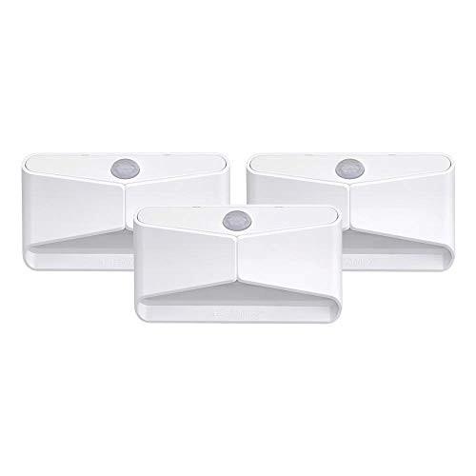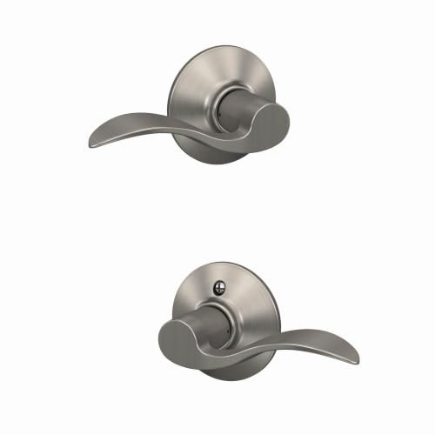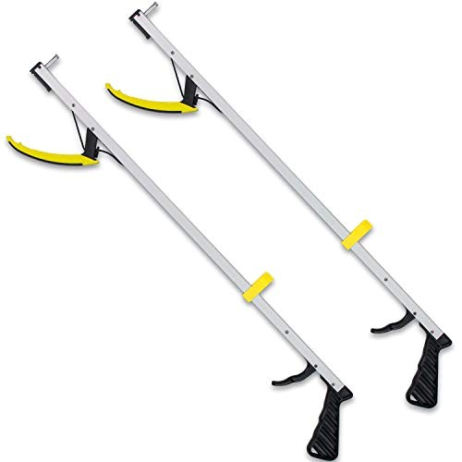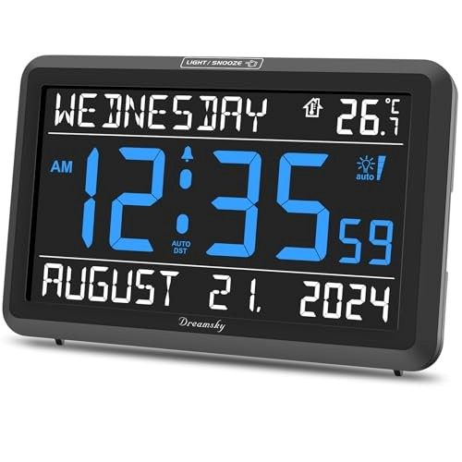
Mr. Beams MB710 Motion Night Light
lumens, battery, no wiring
15
Turns on by itself when someone walks past. Good for
the route to the bathroom.
k
Chec
n
price o
n
Amazo
(
https://www.amazon.com/dp/B075NX9H
42
?
tag=ageinplace0d-20
)
Schlage Accent Lever Door Handle
Passage function, reversible
Push it down instead of twisting a round knob. Easier
with sore hands.
Chec
k
price o
n
n
Amazo
(
https://www.amazon.com/dp/B0007PNP2I
?
tag=ageinplace0d-20
)
RMS Featherweight 32 in Reacher
32
in reach, 2 pack
Picks things up off the floor or a high shelf, so nobody
climbs.
DreamSky Large Display Clock
7.6
in screen, day and date
Big numbers with the day and date. Helps with
medication timing.
Chec
k
price o
n
Amazon
(
https://www.amazon.com/dp/B00UZHYXHO
?
tag=ageinplace0d-20
)
Chec
k
price o
n
Amazon
(
https://www.amazon.com/dp/B0D4LZVF5B
?
tag=ageinplace0d-20
)
These are supplies, not the job itself. Amazon does not sell the labour, the permit or the inspection.

